

**Keynote presentations:**

Royal Hospital for Neuro-disability

**An Introduction to Assessment and Management of Communication in Complex Brain Injury**

**One day course for Speech & language therapists working with brain injury and**

**neuro-disability**

**Thursday 10th November 2016**

**Venue: The Royal Hospital for Neuro-disability, London, UK**



**Royal Hospital for Neuro-disability**

**London SW15 3SW**

**Learning Objectives:**

* Introduction to complex brain injury including disorders of consciousness, cognitive communication impairment, challenging behaviour, and locked in syndrome.
* Consider principles and practicalities when assessing the communication needs of this client group.
* Gain increased knowledge of therapy approaches including Facial Oral Tract Therapy and AAC.
* Case studies will be used for illustration
* Lectures will be given by Speech and language therapists from the Royal Hospital for Neuro-disability

**PROVISIONAL PROGRAMME (may be subject to changes)**

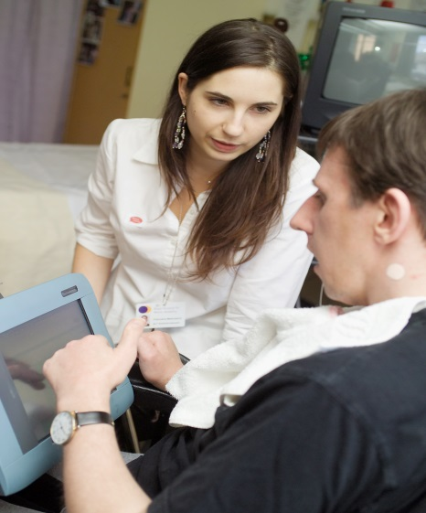

|  |  |
| --- | --- |
| 08.30 | Registration and refreshments |
| 09.00 | Introduction |
| 09.10 | Management of disorders of consciousness |
| 10.10 | Facial Oral Tract Therapy (F.O.T.T) and communication |
| 11.10 | Break |
| 11.30 | Working with locked in syndrome |
| 12.15 | Using augmentative and alternative communication (AAC) |
| 13.15 | Lunch |
| 14.15 | Working with cognitive communication disorders |
| 15.15 | Case study practical |
| 16.00 | Questions and discussion |

**Cost per delegate: £120**

[**www.rhn.org.uk/communication**](http://www.rhn.org.uk/communication)

**Or contact: Phili Denning, E: institute@rhn.org.uk, T: +44 208 780 4500 x 5140**

**The Royal Hospital for Neuro-disability, West Hill, Putney, London SW15 3SW**

**An Introduction to Assessment and Management of Communication in**

**Complex Brain Injury**

**November 10th 2016**

**Registration Form**

|  |
| --- |
| Title: . First Name: Click here to enter text. Surname: Click here to enter text. |
| Job Title: Click here to enter text. Organisation: Click here to enter text. |
| Address: Click here to enter text.  Postcode: Click here to enter text. |
| Telephone: Click here to enter text. Mobile: Click here to enter text.  Email: Click here to enter text. |
| Special dietary or other requirements: Click here to enter text. |
| **PAYMENT METHODS:-** (Please tick your chosen method)  **Cheque:** Please make cheque payable to **The Royal Hospital for Neuro-disability** and send for the attention  of Phili Denning  **Credit Card:**  Card number: Click here to enter text. Valid From: Click here to enter text.  Expiry Date: Click here to enter text. Security code: Click here to enter text.  **Invoice: PO or other reference number:** Click here to enter text.  **Invoicing address:** Click here to enter text.  **Accounts payable contact email**: Click here to enter text. **Accounts payable contact tel**: Click here to enter text.  **☐ BACS**  Please send to the following Natwest Bank, RHN General Account  4165 5273  6 0 2 0 0 9  Sort code Account no.  4 1 6 5 5 2 7 3  Please send your BACS remittance form as confirmation of payment.  Your BACS reference: Click here to enter text. |
| **If you are not self-funding please confirm who has authorised your attendance at this course and the funding:**  Name: Click here to enter text. Position: Click here to enter text.  Contact email: Click here to enter text. Tel: Click here to enter text. |

**Delegate Fee £120**

**General Information:**

* **Venue :** The Royal Hospital for Neuro-disability, London.
* **Course fees include refreshments and lunch**
* **Cancellations/refunds :** A refund, less 20% administration fee will be made if cancellations are received in writing at least 4 weeks before the course. We regret that regret that refunds cannot be made for cancellation or non-attendance after this time. Substitute attendees are welcome at any time.
* **Data Protection:** The RHN will hold your details for the purposes of marketing. This information will not be passed on to 3rd parties

Please return this form (one per applicant) to:

**Phili Denning, Conference Organiser, Email:**  [**institute@rhn.org.uk**](mailto:institute@rhn.org.uk)

**The Royal Hospital for Neuro-disability, West Hill, Putney, London SW15 3SW, UK.**