An Introduction to Thermoplastic Splinting of the Upper Limb in Neurological Conditions
Tuesday 21 – Wednesday 22 May 2019
Royal Hospital for Neuro-disability, London UK

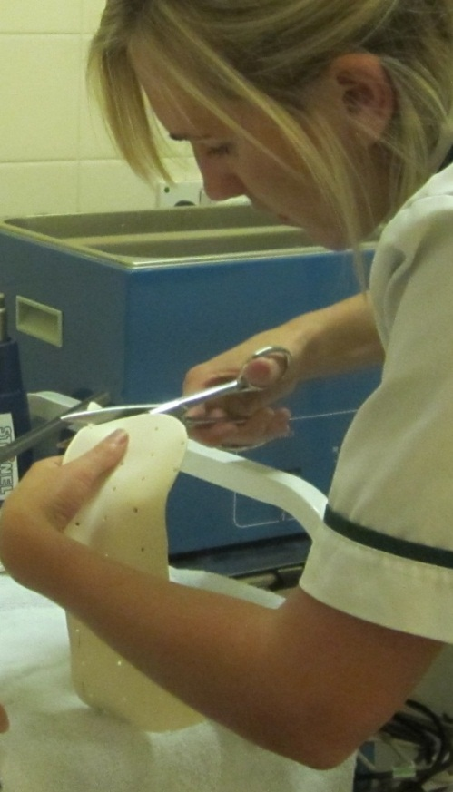
An exciting opportunity to attend an intensive course and learn about the challenges of splinting abnormal tone with complex pathologies such as acquired brain injury and disorders of consciousness.

This course is designed for clinicians, who have some basic experience of working with thermoplastic materials and wish to gain further handling skills and understanding of splinting the neurologically impaired upper limb.

Attendees will develop knowledge of the clinical reasoning behind splinting in neurology through theoretical and practical workshops, with all materials provided throughout the course.

Places are limited so please book early to avoid disappointment.

Cost per delegate £330

Contact:
institute@rhn.org.uk / (+44 0)208 780 4500 x5140

Provisional Programme

Day 1 Tuesday 21 May
8.45am | Registration and refreshments
9.00am | Housekeeping and welcome
9.15am | Upper limb anatomy and function
10.15am | Refreshments
10.30am | Medical management of hypertonicity
12.00pm | Assessment and principles of handling
12.30pm | Lunch
1.30pm | Case study
2.00pm | Refreshments
2.15pm | Thermoplastic practical - cone
3.15pm | Thermoplastic Practical – Volar dorsal splint
4.30pm | Close

Day 2 Wednesday 22 May
8.45am | Refreshments
9.00am | Clinical reasoning and evidence base – journal discussion
10.30am | Refreshments
10.45am | Considering abnormal tone & splinting in relation to function
11.45am | Case study
12.15pm | Thermoplastic practical – Mid-position resting splint
1.00pm | Lunch
2.00pm | Trouble shooting - Delegates patient examples / Clinical reasoning & Fabrication / Prefabricated splints
2.30pm | Refreshments
2.45pm | Thermoplastic practical – thumb spica splint
3.30pm | Thermoplastic practical – wrist cock up splint
4.15pm | Questions/discussions and free practical finishing time
4.30pm | Close

An Introduction to Thermoplastic Splinting of the Upper Limb in Complex Neurological Conditions. May 21-22 2019
Registration form
☐ Delegate fee (£330)

Title: Click here to enter text.. First Name: Click here to enter text. Surname: Click here to enter text.
Job Title: Click here to enter text. Organisation: Click here to enter text.
Address: Click here to enter text.

Postcode: Click here to enter text.

Telephone: Click here to enter text. Mobile: Click here to enter text.

Email: Click here to enter text.

Special dietary or other requirements: Click here to enter text.

PAYMENT METHOD (Please tick your chosen method)

☐ Credit Card: We accept debit and credit card payments. Please contact 0208 780 4500 x5141/5140 to pay securely over the phone.

☐ Invoice: INVOICE REQUESTS WILL NOT BE ACCEPTED IF A PO/REFERENCE NUMBER IS NOT PROVIDED

PO or other reference number: Click here to enter text.

Invoicing address: Click here to enter text.

Accounts payable contact email: Click here to enter text. Accounts payable contact tel: Click here to enter text.

☐ BACS Please send to the following Natwest Bank, RHN General Account
4 1 6 5 5 2 7 3
6 0 2 0 0 9
Sort code Account no.
4 1 6 5 5 2 7 3

Please send your BACS remittance form as confirmation of payment.

Your BACS reference: Click here to enter text.

☐ Cheque: Please make cheque payable to The Royal Hospital for Neuro-disability and send for the attention
of Phili Denning

If you are not self-funding please confirm who has authorized your attendance at this course and the funding:

Name: Click here to enter text. Position: Click here to enter text.

Contact email: Click here to enter text. Tel: Click here to enter text.

Do you have an previous splinting/casting experience? If yes please specify:
Click here to enter text.

Please return this form (one per applicant) to Phili Denning, Academic Event Manager at institute@rhn.org.uk – or by post: Royal Hospital for Neuro-disability, West Hill, Putney, London SW15 3SW United Kingdom

Venue: Royal Hospital for Neuro-disability, London.
Delegate fees include refreshments and lunch.
Cancellations/refunds: A refund, less 20% administration fee will be made if cancellations are received in writing at least 4 weeks before the course. We regret that refunds cannot be made for cancellation or non-attendance after this time. Substitute attendees are welcome at any time.

