An Introduction to Thermoplastic Splinting of the Upper Limb in Neurological Conditions
Monday 14 May – Wednesday 16 May 2018
Royal Hospital for Neuro-disability, London UK

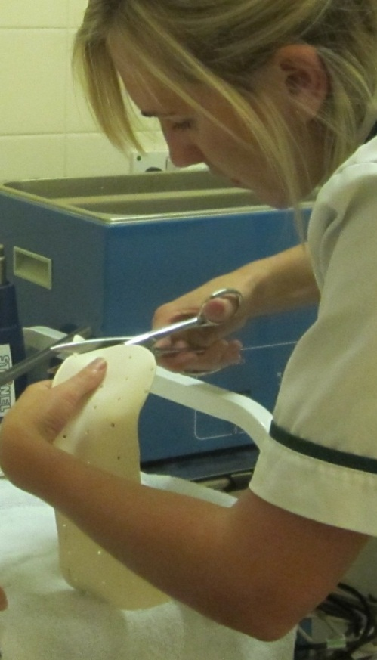
An exciting opportunity to attend an intensive course and learn about the challenges of splinting abnormal tone with complex pathologies such as acquired brain injury and disorders of consciousness.

This course is designed for clinicians, who have some basic experience of working with thermoplastic materials and wish to gain further handling skills and understanding of splinting the neurologically impaired upper limb.

Attendees will develop knowledge of the clinical reasoning behind splinting in neurology through theoretical and practical workshops, with all materials provided throughout the course.

Places are limited so please book early to avoid disappointment.

Cost per delegate £389* ^{(lunch not provided)}

Contact:
institute@rhn.org.uk / (+44 0)208 780 4500 x5140

Provisional Programme
Day 1 Monday 14 May
9.00am | Registration and refreshments
9.15am | Housekeeping and welcome
9.30am | Upper limb anatomy and function
10.45 | Refreshments
11.00am | Medical management of hypertonicity
12.15pm | Lunch
1.00pm | Considering abnormal tone and splinting
2.15pm | Assessment and principles of handling
3.00pm | Thermoplastic practical - cone
3.30pm | Close
Day 2 Tuesday 15 May
9.00am | Refreshments
9.15am | Clinical reasoning and evidence base – journal discussion
10.45am | Refreshments
11.00am | Thermoplastic practical - gutter
12.00pm | The good, the bad and the ugly case study
12.45pm | Lunch
1.30pm | Thermoplastic practical – mid position resting splint
3.15pm | Resting mitt / Free practice and discussion
3.30pm | Close
Day 3 Wednesday 16 May
9.15am | Thermoplastic practical – volar dorsal
10.30am | Refreshments
10.45am | Resting mitt / functional splints and adaptations – free practice and discussion
12.30pm | Lunch
1.15pm | Case study – trouble shooting
2.15pm | Delegates problem patient examples / Clinical reasoning and fabrication / Practical time
3.15pm | Questions
3.30pm | Close

An Introduction to Thermoplastic Splinting of the Upper Limb in Complex Neurological Conditions. May 14 – 16 2018
Registration form
☐ Delegate fee (£389)
Please return this form (one per applicant) to Phili Denning, Academic Event Manager at institute@rhn.org.uk – or by post: Royal Hospital for Neuro-disability, West Hill, Putney, London SW15 3SW United Kingdom
Title: Click here to enter text.. First Name: Click here to enter text. Surname: Click here to enter text.
Job Title: Click here to enter text. Organisation: Click here to enter text.
Address: Click here to enter text.

Postcode: Click here to enter text.

Telephone: Click here to enter text. Mobile: Click here to enter text.

Email: Click here to enter text.

Special dietary or other requirements: Click here to enter text.

PAYMENT METHOD (Please tick your chosen method)

☐ Cheque: Please make cheque payable to The Royal Hospital for Neuro-disability and send for the attention
of Phili Denning

☐ Credit Card

Card number: Click here to enter text. Valid From: Click here to enter text.

Expiry Date: Click here to enter text. Security code: Click here to enter text.

☐ Invoice: PO or other reference number: Click here to enter text.

Invoicing address: Click here to enter text.

Accounts payable contact email: Click here to enter text. Accounts payable contact tel: Click here to enter text.

☐ BACS Please send to the following Natwest Bank, RHN General Account
4 1 6 5 5 2 7 3
6 0 2 0 0 9
Sort code Account no.
4 1 6 5 5 2 7 3

Please send your BACS remittance form as confirmation of payment.

Your BACS reference: Click here to enter text.

If you are not self-funding please confirm who has authorized your attendance at this course and the funding:

Name: Click here to enter text. Position: Click here to enter text.

Contact email: Click here to enter text. Tel: Click here to enter text.

Do you have an previous splinting/casting experience? If yes please specify:
Click here to enter text.

Venue: Royal Hospital for Neuro-disability, London.
Conference fees include refreshments. You will need to provide your own lunch. A canteen and café are available on site for hot and cold food.
Cancellations/refunds: A refund, less 20% administration fee will be made if cancellations are received in writing at least 4 weeks before the course. We regret that refunds cannot be made for cancellation or non-attendance after this time. Substitute attendees are welcome at any time.

