A Multi-disciplinary Approach to the Assessment and Management of Huntington’s Disease
Monday 11 October 2021
Royal Hospital for Neuro-disability, London UK

This comprehensive and in-depth online course is aimed at Allied Health Professionals (including physiotherapists, speech and language therapists, occupational therapists, psychologists, dietitians, music therapists), nurses, healthcare assistants, and doctors/GPs working in community or inpatient settings

Huntington’s Disease (HD) is a hugely complex progressive neurological condition. This course will enrich your knowledge of HD, give a thorough overview of multiple aspects of assessment and management, and will provide you with practical ideas to take away.

Led by the specialist multi-disciplinary team from the dedicated HD unit at the RHN, the course will include:

- An introduction to Huntington’s Disease and medical management
- Working with cognitive impairments
- Working with communication impairments
- Emotional and behavioural aspects of Huntington’s Disease
- Mobility and postural management
- Nutrition and swallowing including advanced decision planning
- Promoting quality of life and independence through participation.

Lead facilitator

Rosanne Tyas, Professional Lead for Music Therapy
Royal Hospital for Neuro-disability

Cost per delegate: £65
(Student rate: £55)

Contact:
institute@rhn.org.uk / (+44 0)208 780 4500 x5140

A Multi-Disciplinary Approach to the Assessment and Management of Huntington’s Disease

Provisional programme

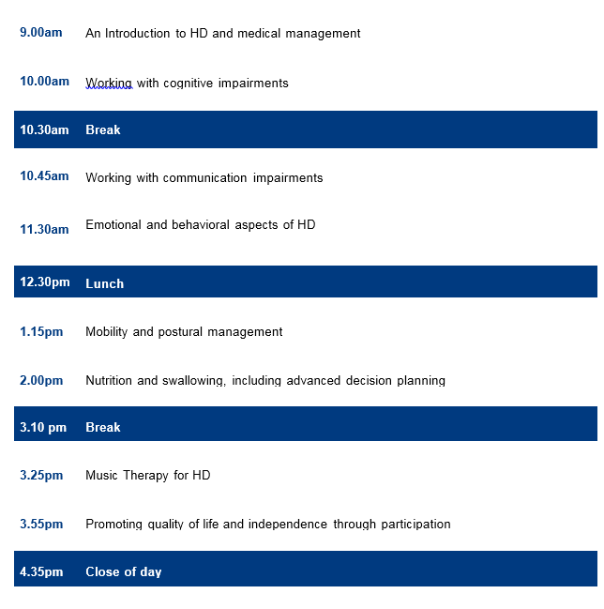

Please note this programme may be subject to change
A Multi-disciplinary Approach to the Assessment and Management of Huntington’s Disease, 11 October 2021
Registration form
☐ Standard rate (£65)
☐ Student rate (£55)
Title: Click here to enter text. First Name: Click here to enter text. Surname: Click here to enter text.
Job Title: Click here to enter text. Organisation: Click here to enter text.
Address: Click here to enter text.

Postcode: Click here to enter text.

Telephone: Click here to enter text. Mobile: Click here to enter text.

Email: Click here to enter text.

Special dietary or other requirements: Click here to enter text.

PAYMENT METHOD (Please tick your chosen method)

☐ Credit/Debit Card: We accept debit and credit card payments; please contact 020 8780 4500 Ext. 5141/5140 to pay securely by phone

☐ Invoice: INVOICE REQUESTS WILL NOT BE ACCEPTED IF A PO/REFERENCE IS NOT PROVIDED
PO or other reference number: Click here to enter text.

Invoicing address: Click here to enter text.

Accounts payable contact email: Click here to enter text. Accounts payable contact tel: Click here to enter text.

☐ BACS Please send to the following Natwest Bank, RHN General Account
4 1 6 5 5 2 7 3
6 0 2 0 0 9
Sort code Account no.
4 1 6 5 5 2 7 3

Please send your BACS remittance form as confirmation of payment.

Your BACS reference: Click here to enter text.

☐ Cheque: Payable to The Royal Hospital for Neuro-disability and send for the attention of Anna Harlow

If you are not self-funding please confirm who has authorised your attendance at this course and the funding:

Name: Click here to enter text. Position: Click here to enter text.

Contact email: Click here to enter text. Tel: Click here to enter text.

Please add me to the mailing list to receive information about future RHN academic events ☐

Please return this form (one per applicant) to Anna Harlow, Academic Event Manager at institute@rhn.org.uk – or by post:
Royal Hospital for Neuro-disability, West Hill, Putney, London SW15 3SW United Kingdom
Venue: Royal Hospital for Neuro-disability, London.
Cancellations/refunds: A refund, less 20% administration fee will be made if cancellations are received in writing at least 4 weeks before the course. We regret that refunds cannot be made for cancellation or non-attendance after this time. Substitute attendees are welcome at any time.

